Sign in Process
- Lets remove the google sign in all together, force them to sign up using email and password and ensure that there is a confirmation email sent and confirmed before allowing them to do anything i.e. when they place paper bet or try talk to bob or blackbook or whatever, an alert comes up to please confirm account via email - something better than that
- We also need to add a checkbox for opt-in to marketing on the sign in page.
- When you firsdt log in, it loadfs to Home (previously dashboard), it no longer defaults to racing. When you log in to home It should display your next blackbookers with an option to open blackbook, high ev chances with option to add to betslip, next racing and next sport – Instaead of 4 cards, let’s do 1 card that is default to high ev feed with tabs for the other items on top of the card

UI/UX Changes
- Remove the sidebar and menu all together its not needed
- Remove all this refreshing stuff, there should just be a small refresh button you can hit somewhere that doesn’t take much room, when it is refreshing it spins or something to show it is loading.
- 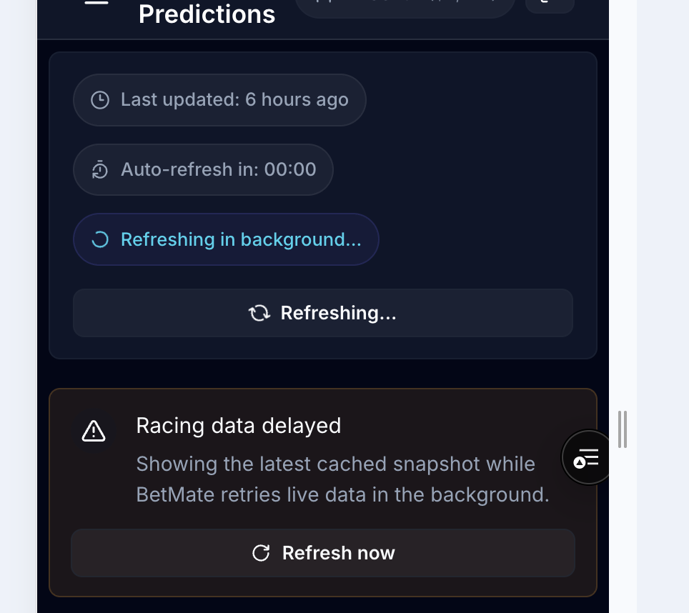
- With the bottom menu, you can see how the “ask bob” feature floats over the “more section” of the menu. Let’s re,ove the more section., we don’t need it anyway. We can put a how it works somewhere else later on. Instrad of the floating bob, let’s implement him in the bottom menu where the “more”section iss. Shrink logo to fit in menu
- Add Analytics to the lab and make that page professional, it looks tacky with the massive bob logo on that ask bob card. I think that all the cards on this page can be shrunk by 5% height, that will mae it flow better.
- Ensure the strategies are actually placing bets everyday, ad these need to be recorded and used in the ML engine for learning aswell as tracked in analytics so people can see which strategies are doing well at different times
- Ensure ALL racing and sport are loading into RACING, SPORT and the next racing, next sport sections on the Home page
- Ensure bets of users and strategies are placed and tracked (comes off the bankroll for the week and tracked in ML for learning), scored on the leaderboards, and the strategies go on the leaderboards also. Once the bets are settled the leaderboards updated after the cron job at 4am when bets get settles.
- Overall the loading of strategy cards, races, sports etc is takin glonger than it used to. Look for ways to optimize how the data is received and displayed to speed this process up

